The Yoke

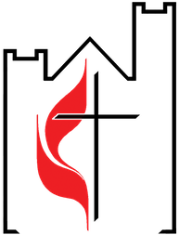

**BIRTHDAY SUNDAY AND ALL OTHER ACTIVITIES CANCELLED UNTIL FURTHER NOTICE**

**INSIDE this issue**

**THE YOKE- August 2020**

A PUBLICATION OF PEOTONE UNITED METHODIST CHURCH

VISIT US ONLINE **www.peotoneumc.com**

**SUNDAY SERVICE RETURNS**

***In co-operation with requirements set forth by state government and the Northern Illinois Conference, please follow these social distancing guidelines when attending services:***

-Only sit in the approved areas pre-marked

-PLEASE BRING AND WEAR A MASK

-Please take home your bulletin. Do not leave in pew or discard at church. Please do not discard ANY garbage at the church, including tissues and gum or candy wrappers, etc.

-The offering plates and bulletins will be on the table at the back of the church. These will NOT be passed around. Please take a bulletin and submit your offering at the table.

-NO COFFEE HOUR

**The Will County Fair**

has been cancelled this year.

We will miss the **Community Worship Service** at the fair on Fair Sunday.

May God bless and care for our sisters and brothers in Peotone area congregations.

**“Every saint has a past. Every sinner has a future.”  
—Stanley Hauerwas**

Table of Contents/ News……………………..…1

A Message from your Pastor………….….…..2

Numbers for Good…………….….………….…...3

In Our Prayers…………………………….......……4

The Christian Review………………….….………5

Activities……………………….………….….……….6

Calendar………………………….…………….………7

Cover……………………………..……………………..8

Coming this fall

DISCIPLE

**Bible Study**

*Jesus in the Gospels*

(This study looks at the way each Gospel writer

presents events and teachings and at the picture of Jesus that emerges in each Gospel.)

Led by Pastor Richard Young

**Since its introduction in 1987, DISCIPLE has made a significant difference in the lives of thousands of participants throughout the world.**

DISCIPLE is a program of disciplined Bible Study aimed at developing strong Christian leaders.

**DISCIPLE provides the fellowship of the small group for study, prayer, and preparation for servanthood.**

**DISCIPLE assumes that the Bible provides the key to renewal in the church.**

**DISCIPLE draws upon the work of scholars to aid understanding of the Bible.**

This study will take place in 2 sections: September through November, and mid-January through mid-May.

The study will begin through ZOOM teleconferencing and will become in-person only if and when we are assured that it is safe for all.

You are invited to join in this adventure in spiritual formation!

Dear Friends,

Commitment gives meaning to human relationships. We find fulfillment in relationship when we learn that we really can count on that other person. When we hurt and have needs, they are there. When we need to talk, they are available.

In larger relationships, commitment is an agreement to work together for the good of the larger group so that each one can have a place and a sense of security. It is based on the idea that by giving what we have to give, some larger good will emerge. At its best, commitment is something we do because we have come to believe that it is the “right thing” to do.

Commitment costs something. Commitment requires giving—time, resources, creativity, and much more. When we see it evidenced in others, we admire them. When we think about it for ourselves, we become fearful. Commitment requires giving something of our very selves, so that we are no longer totally our own.

The most powerful demonstration of commitment is seen in God’s commitment to us as it is evidenced in God’s gift of Jesus Christ. On the basis of that commitment to us, God calls us to be committed to God and to one another. In a real sense, our commitment to one another is an indication of our commitment to God.

Some say these days that commitment is fading away in our culture. We tend to become so bound up in ourselves and in our things that at best we make shallow commitments to others.

I am thankful that in the life of the faith community, I have found commitment to be alive and well. So often, one of you impacts my life with the depth of your commitment to this faith community and to God. So often I see some sign that others are responding to God in meaningful commitment. Thank you!!!

See you soon,

FROM THE PASTOR:

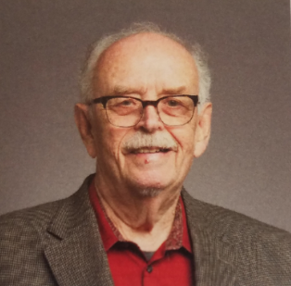

**RLY**

Pastor Richard Young

**LITURGISTS FOR AUGUST**

**August 2- Kathy Carter Young**

**August 9- Jane Jones**

**August 16- Amy Maupin**

**August 23- Libby Nelson**

**August 30- Alan Gillis**

**COMMITTEE MEETINGS**

***COMMITTEES WILL CORRESPOND VIA EMAIL***



16- James & Sheila Zdzinicki

23- Terry & Debbie Brozowski

31- Bill & Sandi Klien

01- Dale Schmidt

03- Sherry Morrison

06- Tim Knecht

07- Ann Loitz

08- Emma Pena

09- Cheryl Dralle

Richard Young

11- Ian Young

14- Mike Strubhar

Taylor Zdzinicki

15- Sharon Johnston

18- Andrew Bittner

21- Ginger Saliba

23- Layla Pietrzak

24- Cody Nelson

25- Lynn Temme

27- Tari Knecht

**August Birthdays**

**August Anniversaries**

**FACTS & FIGURES FOR JULY**

ATTENDANCE / OFFERING TOTALS

July 5 18 1692.00

July 12 18 2097.00

July 19 20 2420.00

July 26 21 1519.75



Pastor Richard & Kathy

Susan Quick

Paul & Nora Johnson

April Sorenson, Donna’s daughter

Doris’ sister Carole

Ann Loitz’s niece

Scott Stuckey

Katie’s grandaughter

Libby’s friend Rick Emerson

Phyllis Baker

Sharon Martin

Ken Cabit

Doreen’s friend

Sharon Martin’s friend

Theresa Agee, Libby’s friend

Heather Nelson and family

Sharon’s son-in-law

Sandra Moutrey

Erica and family

Kathy’s friend

Larry Johnston

Sandi Klien’s sister

Family of Bev Tongren

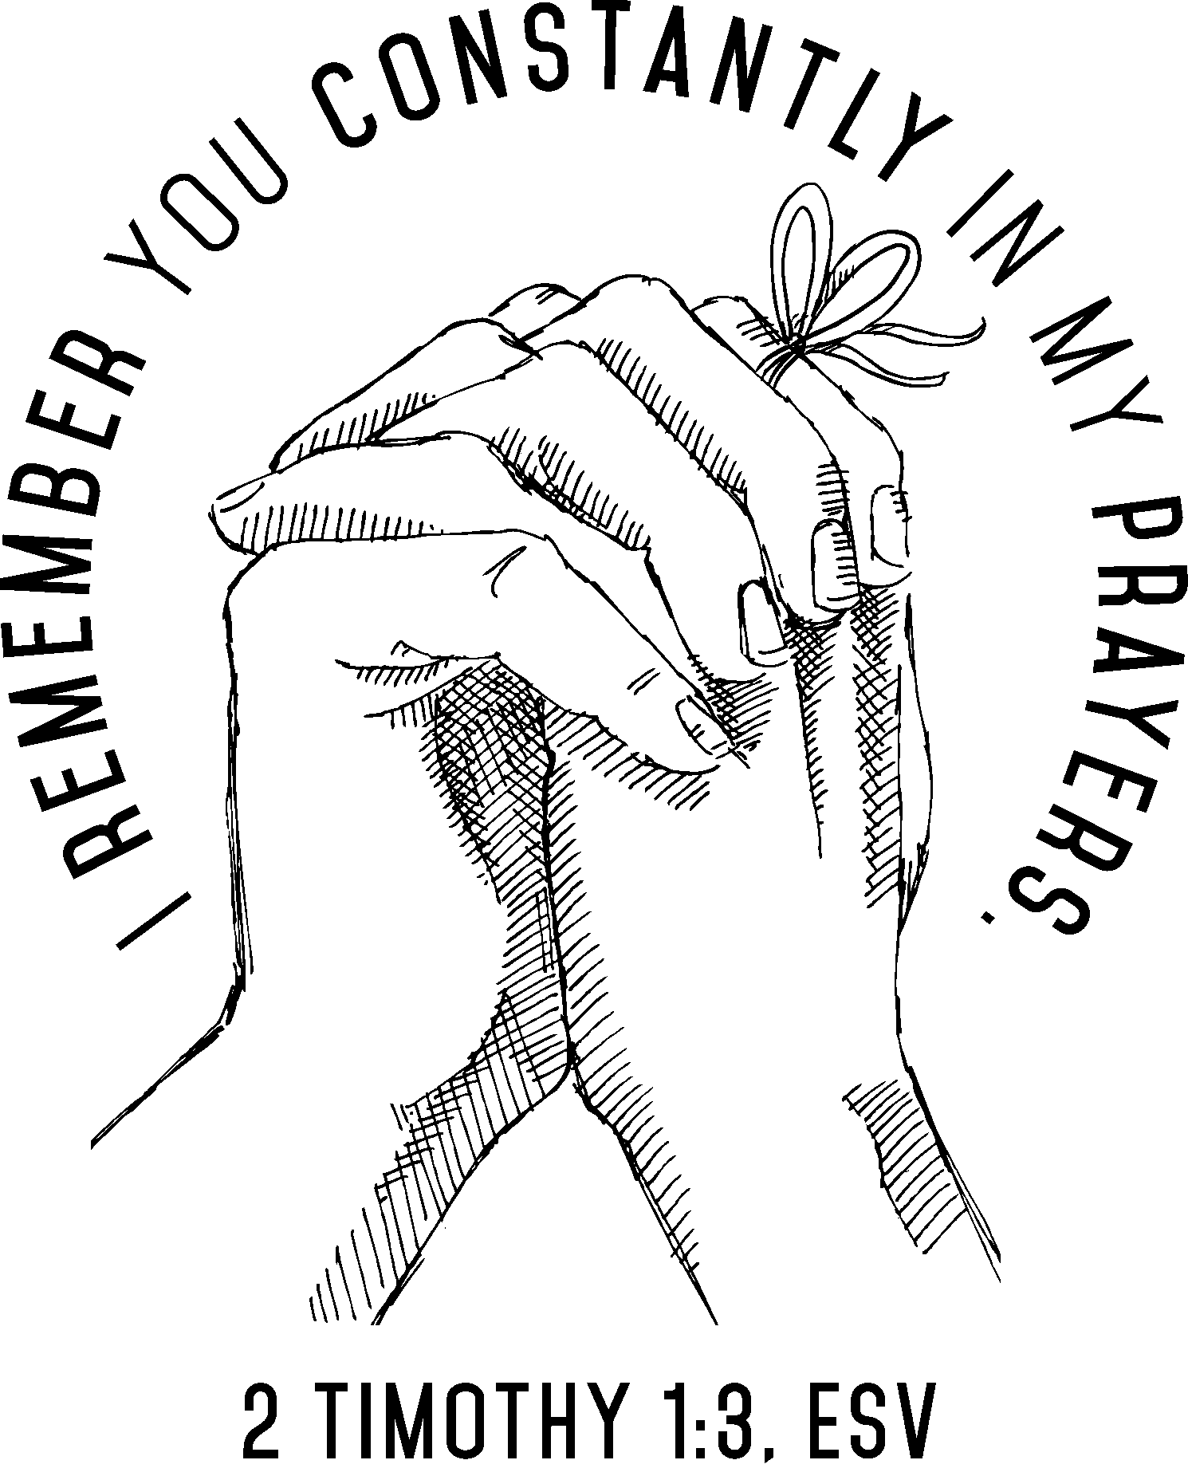

Remember our homebound members!

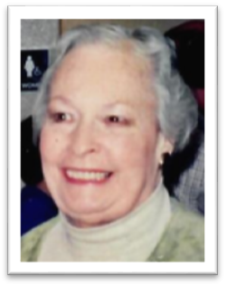

**Beverley E. Tongren**, age 93, of Peotone, passed away on Tuesday, July 21, 2020 at her home surrounded by her loving family.

She was born on November 18, 1926 in Chicago, IL, the daughter of Allan and Esther (Skinner) Brunelle.  Beverley attended and graduated from the University of Illinois.  She married Bill Tongren on February 2, 1951 in Evanston, IL.

Cremation rites have been accorded.  All services will be private.

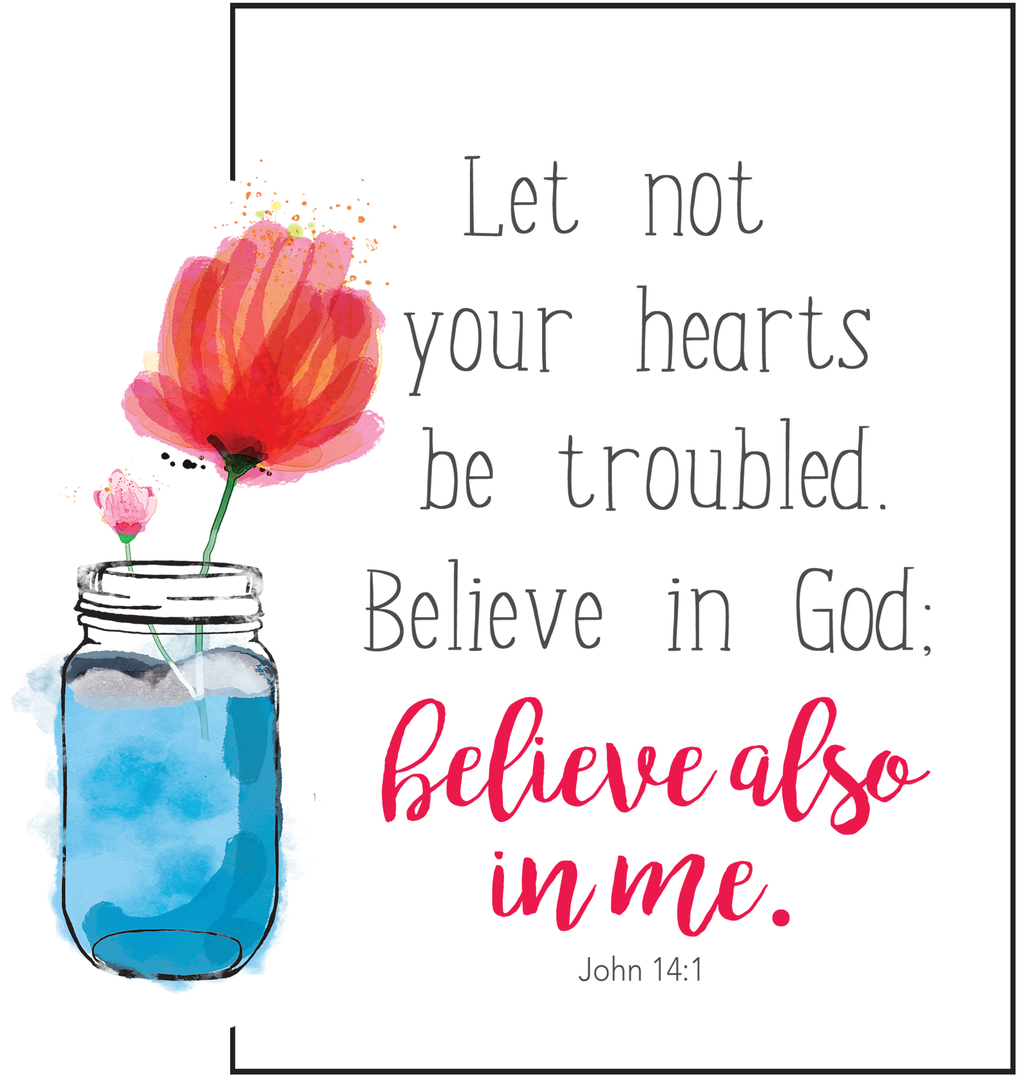

Our Homebound Members

Our members with unspoken requests

Our Church and all Churches

Peotone Schools & School District

All others struggling with health issues

All U. S. Troops

Our National Government

Lillie Buck- Room 111

995 N Entrance Ave

Kankakee, IL 60901

Elyvern Schroeder

31560 S Dixie Highway

Beecher, IL 60401



**The Christian Review**

Last spring, life changed as we became familiar with terms such as social distancing, flattening the curve, and self-quarantining. We could hardly believe the closed school, businesses, and especially churches- just as Holy Week and Easter drew near! The coronavirus ran rampant in the world. Where was God?

But as the spread continued, many civic leaders stepped up, calmly informing us of the facts, of actions being taken to mitigate the crisis and of how we could help. Healthcare professionals risked their lives and endured separation from families; teachers drew on astounding stores of creativity to teach online; pastors delivered sermons and lessons to empty sanctuaries as members listened and prayed while living in quarantine. Surely God was present — through them!

Then I remembered how God assures us through Isaiah, “Fear not! When you pass through the waters, the fires, yes, even the pandemics of this world, I will be with you” (43:1-2, paraphrased). And Jesus echoes, “I am with you always” ([Matthew 28:20](https://biblia.com/bible/esv/Matt%2028.20)).

-Sandy Hyland

**Willow**  
The billowing branches of the “weeping willow” symbolize mourning, especially of the Israelites as they endured captivity. The willow, which grows well in marshy areas, is associated in the Bible with fruitful, well-watered land (see Ezekiel 17:5). In descriptions of Old Testament festivals of praise, God’s people were told “to take branches from luxuriant trees — from palms, willows and other leafy trees — and rejoice before the LORD your God for seven days” (Leviticus 23:40, NIV).

**CHRISTIAN SYMBOL**

**God Amid Pandemic**

**Patient Attention,  
Valuable Discoveries**  
​  
**For many people, the coronavirus pandemic has been a test of patience — or worse. Medically vulnerable people face an anxious time of hypervigilance. Furloughed workers wait on hold or in lines for assistance. Special events have been canceled or rescheduled.  
Those not impacted directly deal with assorted frustrations and inconveniences. Many people are learning the benefit of slowing down, being present (even virtually) to others and practicing patient attention.  
Interestingly, scientist Isaac Newton did some of his best work when the plague forced Cambridge University to close. At home, the inquisitive student invented calculus and developed groundbreaking theories of gravity and optics. Later Newton called 1666 his annus mirabilis (“year of wonders”) and reportedly said, “If I have made any valuable discoveries, it [owes] more to patient attention than to any other talent.”  
What have you discovered during the Covid-19 crisis? What appreciations have you developed for aspects of life you may have previously taken for granted? What has social distancing taught you about the value of neighbors, church, community volunteering?  
During the pandemic, what have you learned about persistence and God’s presence? What empathy do you now feel for writers of words such as “I wait for the LORD, my whole being waits, and in his word I put my hope” (Psalm 130:5, NIV)?**

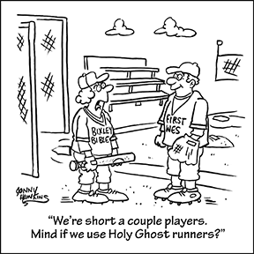

TRIVIA

In John of Patmos’ vision, what is special about the 12 gates of the New Jerusalem?  
  
A. They are made of gold and always closed.  
B. They are made of amethyst and onyx.  
C. They are closed by day and open by night.  
D. They are made of pearl and never closed.

Last month’s trivia answer:   
  
Answer: C (See Matthew 10:42.)

|  |  |  |  |  |  |  |
| --- | --- | --- | --- | --- | --- | --- |
| **SUNDAY** | **MONDAY** | **TUESDAY** | **WEDNESDAY** | **THURSDAY** | **FRIDAY** | **SATURDAY** |
|  |  |  |  |  |  | 1 |
| **2**  *Service 10:30am* | 3 | 4 | 5 | 6 | 7 | 8 |
| **9**  **OPERATIONS**  **Committee Meeting**  *Service 10:30am* | 10 | 11 | 12 | 13 | 14 | 15 |
| **16**  **NOW Committee Meeting**  ***Special Sunday Offering***  ***Helping Hands***  *Service 10:30am* | 17 | 18 | 19 | 20 | 21 | 22 |
| **23**  *Service 10:30am* | 24 | 25 | 26 | 27 | 28 | 29 |
| 30 | 31 |  | **Helping Hands – August**  The NOW Committee encourages you to bring your contributions of the following items to church so they can be delivered to Helping Hands: **PAPER PRODUCTS: toilet paper, paper towels, and tissues.** |  |  |  |

**August 2020**

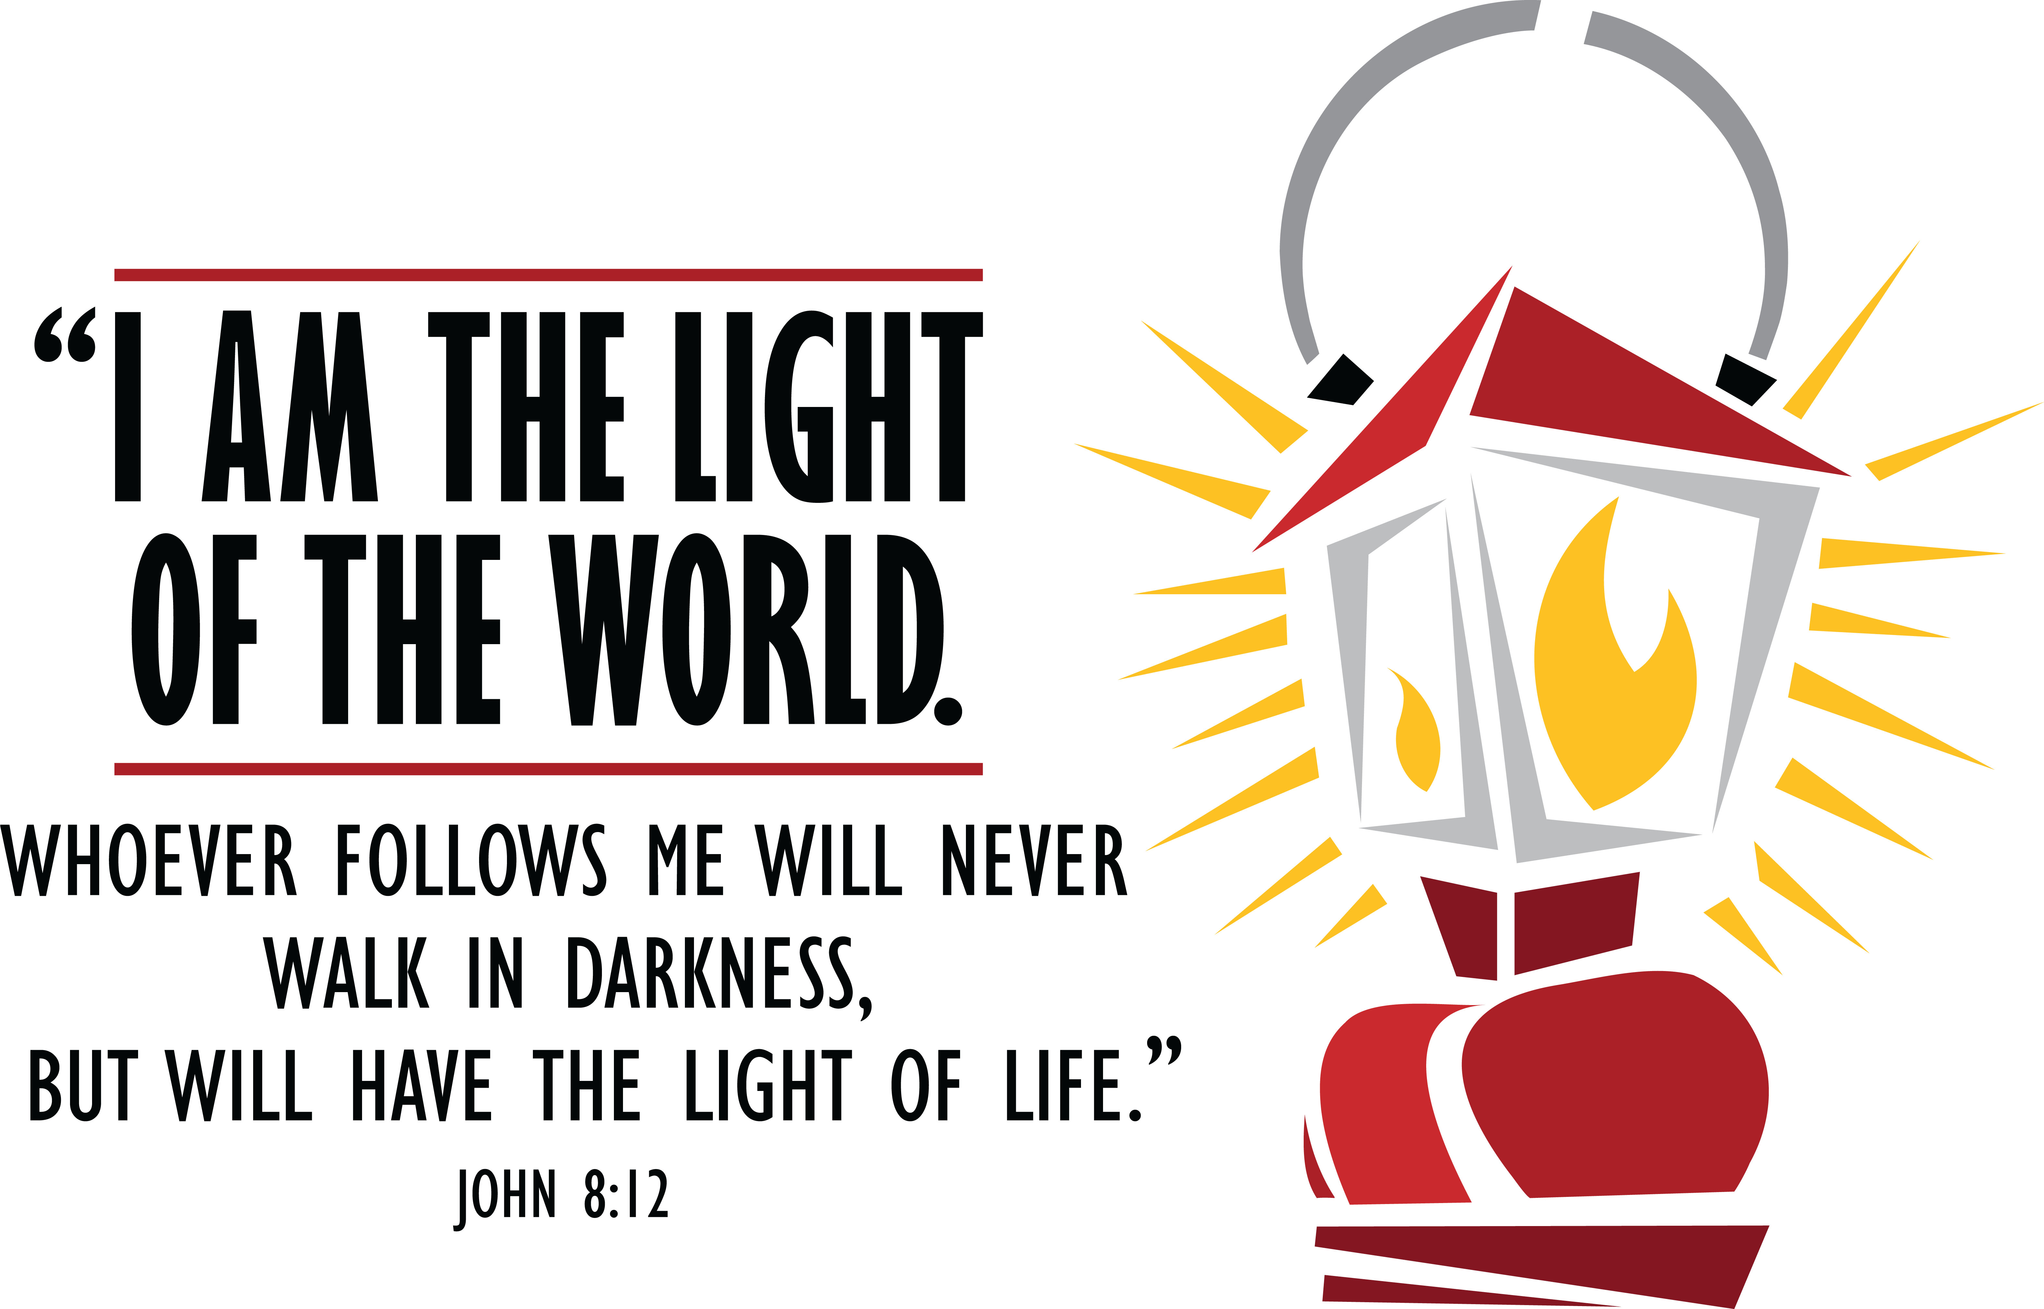

**August 2020**

**Peotone United Methodist Church**

105 N. West St.

Peotone, IL 60468

Phone: (708) 258-6876

www.peotoneumc.com